TESLON SOLUTION LTD
No. 3 EHORO CRESCENT, OFF ODULUKWU STREET ELELENWO, RC 1449137
PORT HARCOURT.
08162561172, 08163806231.

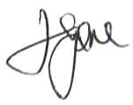
EGERUE NNAMDI JOSEPH EGERUE NGOZI AGATHA
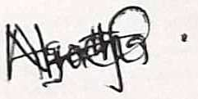
__________________________ -------------------------------------------
DIRECTOR DIRECTOR

